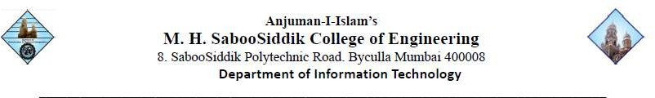

Date:
Name:
Roll No: Year/Semester: TE - VI
Course Name: DS Lab
Course Code: ITL605

Experiment: -

Aim: -

Performance (7M) | Journal (3M) | Lab Ethics (2M) | Attendance (3M) | Total (15M) | Sign

Signature of the Professor:
Er. Farzana Khan

